**Using Packet Tracer, create a network with three routers with RIPv2 and each router associated network will have minimum three PC. Show Connectivity.**

1. Add 3group’s of 3 pc’s

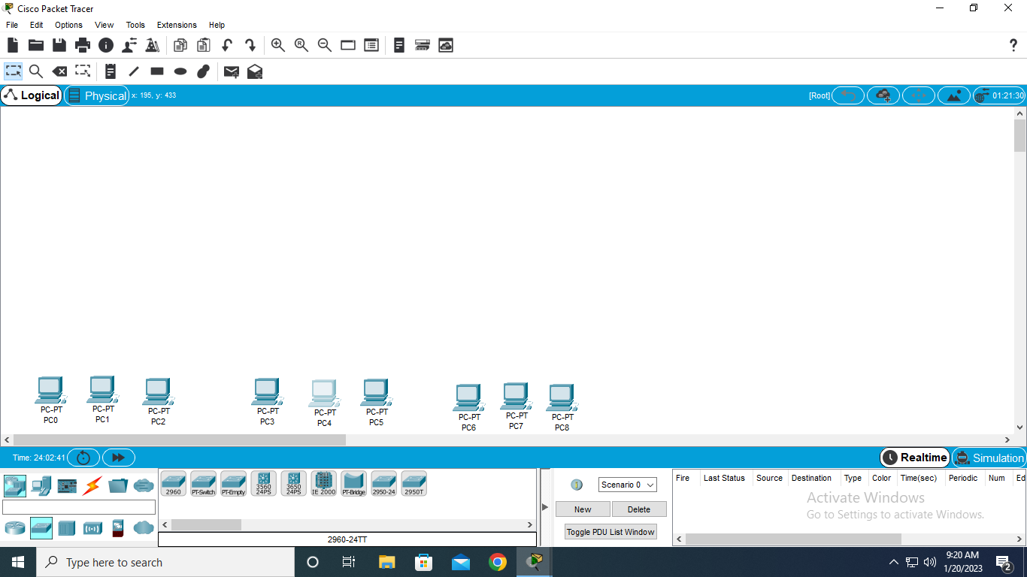

1. Add 3 switches to each group of 2950-24

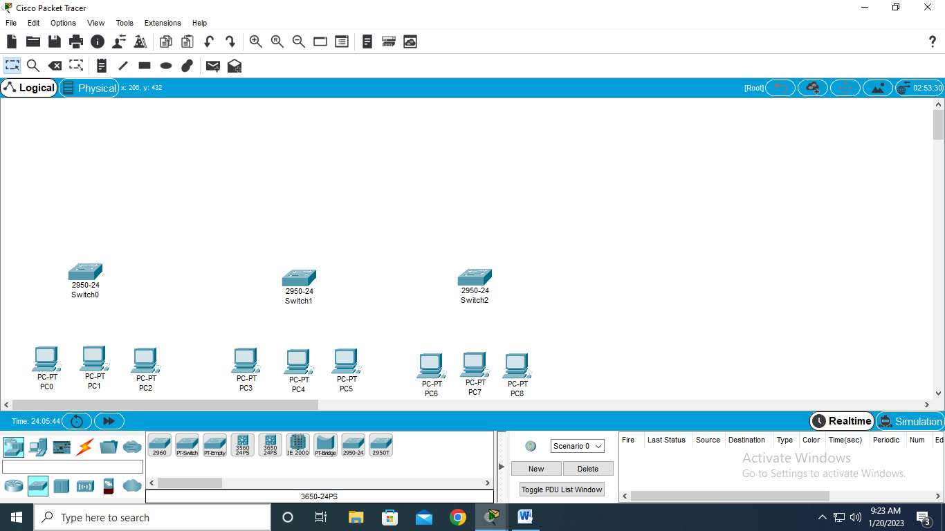

1. Add 3 router’s to each switch with 1841

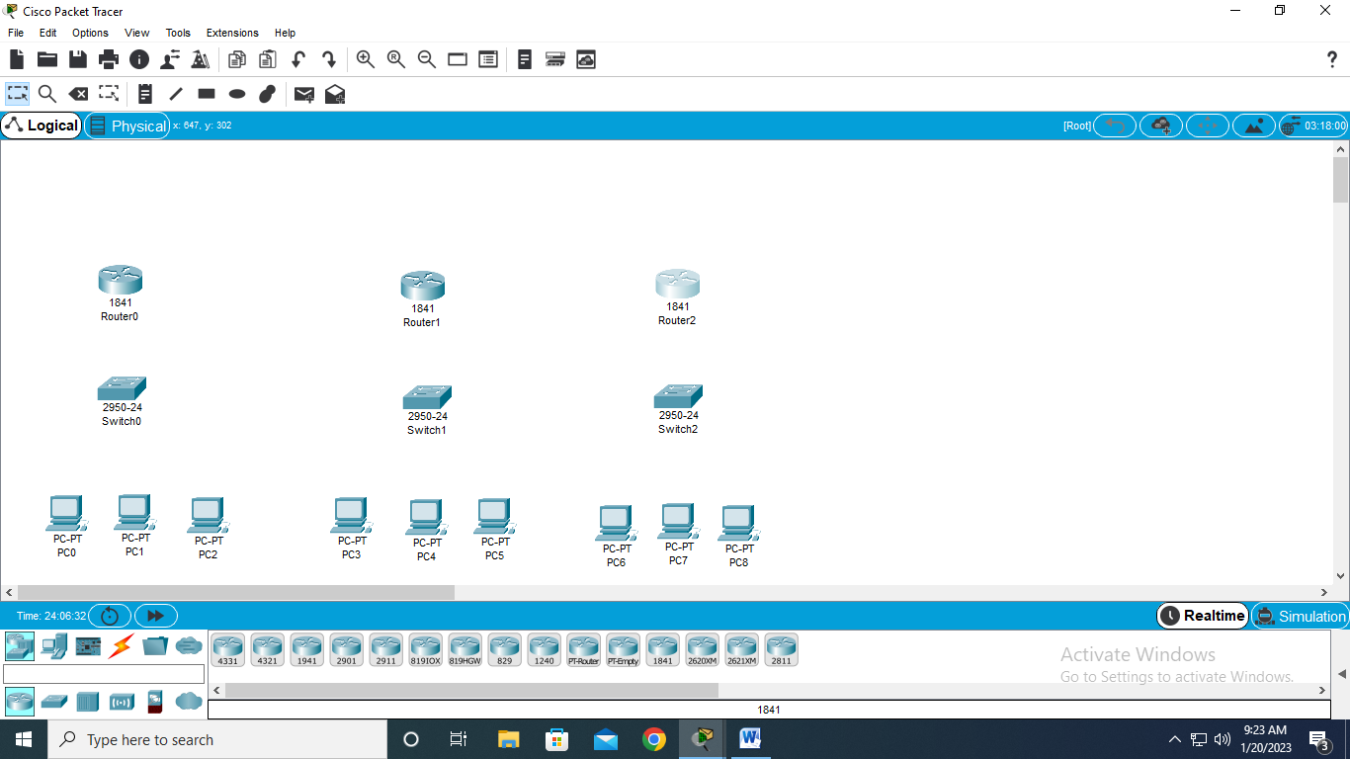

1. Add wire to each group of pc’s to each switch

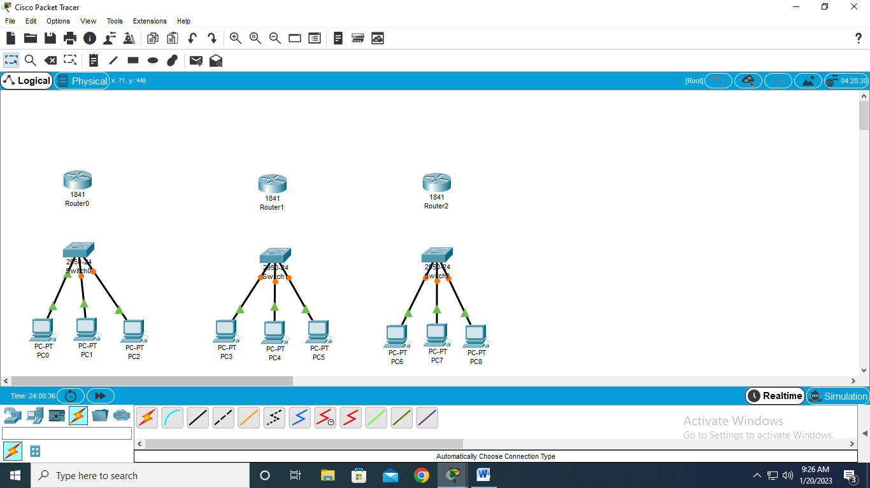

1. Add wire to each router to each switch

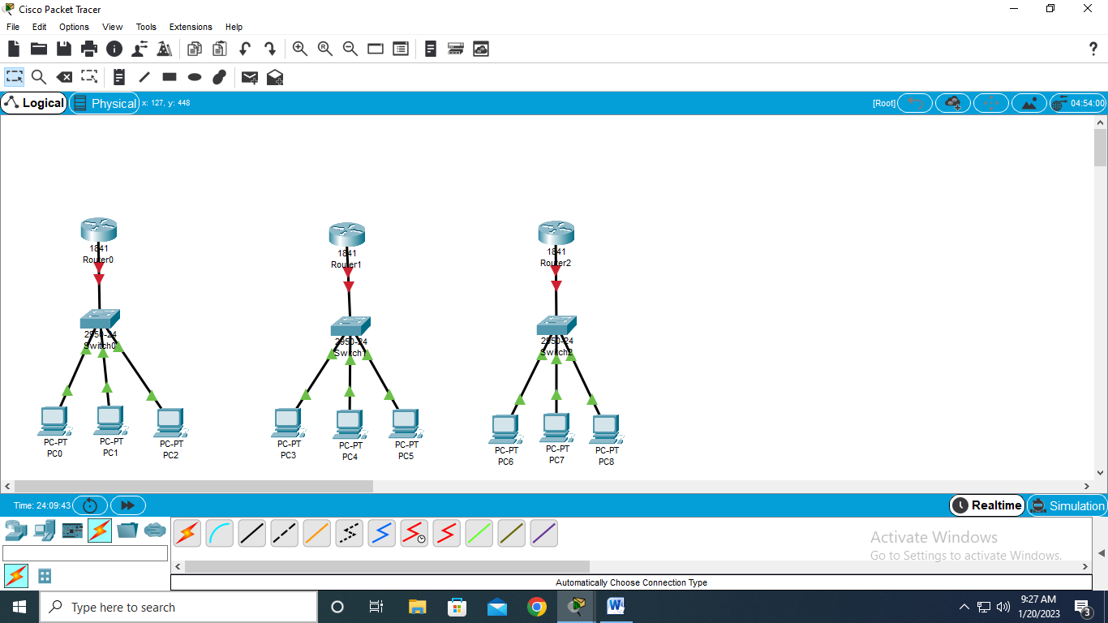

1. Add port to each router-WIC-PT

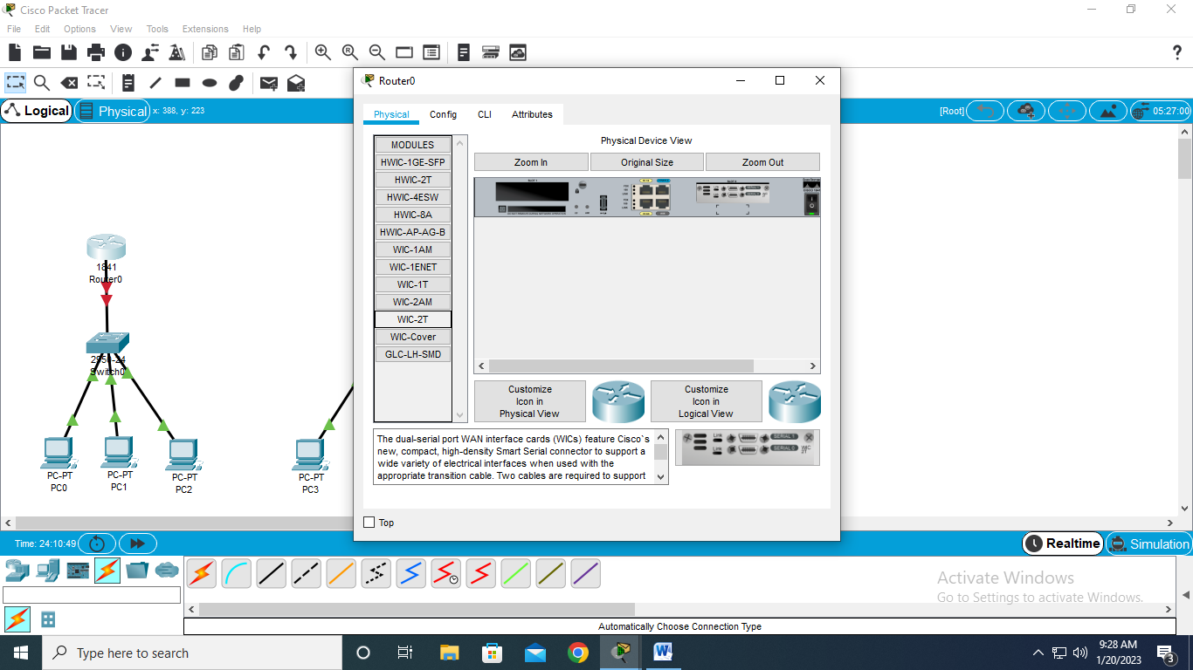

1. Add router’s to each other

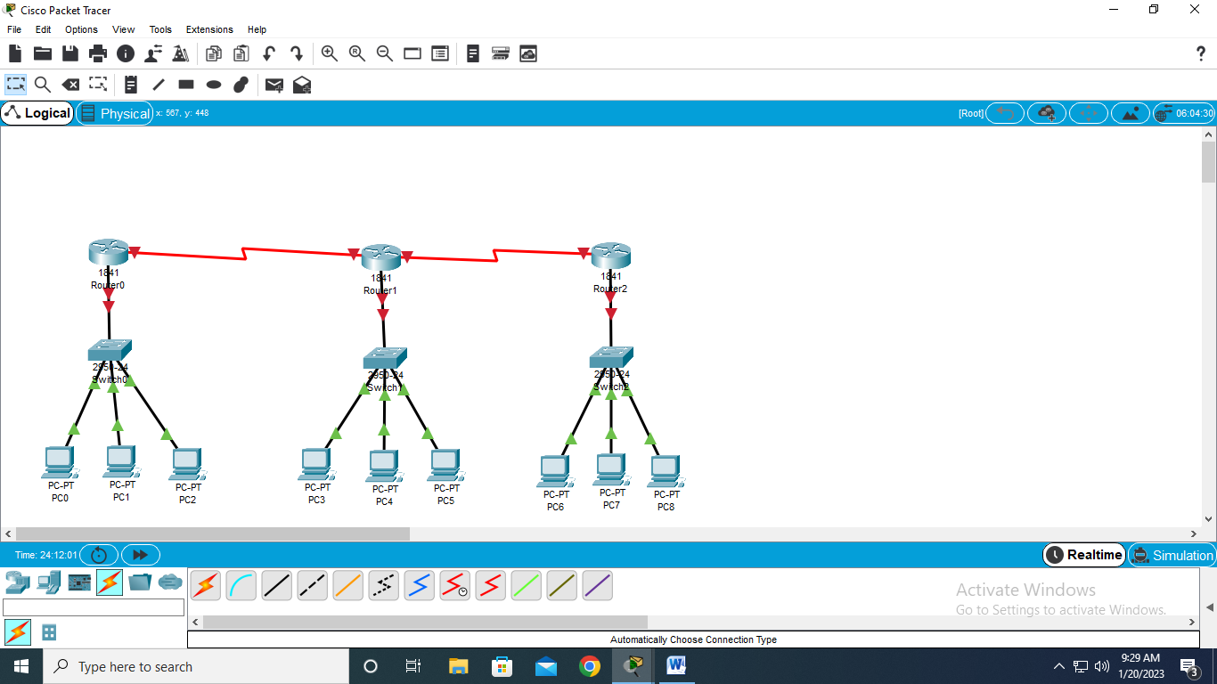

1. Add fastethernet IP address to each router1

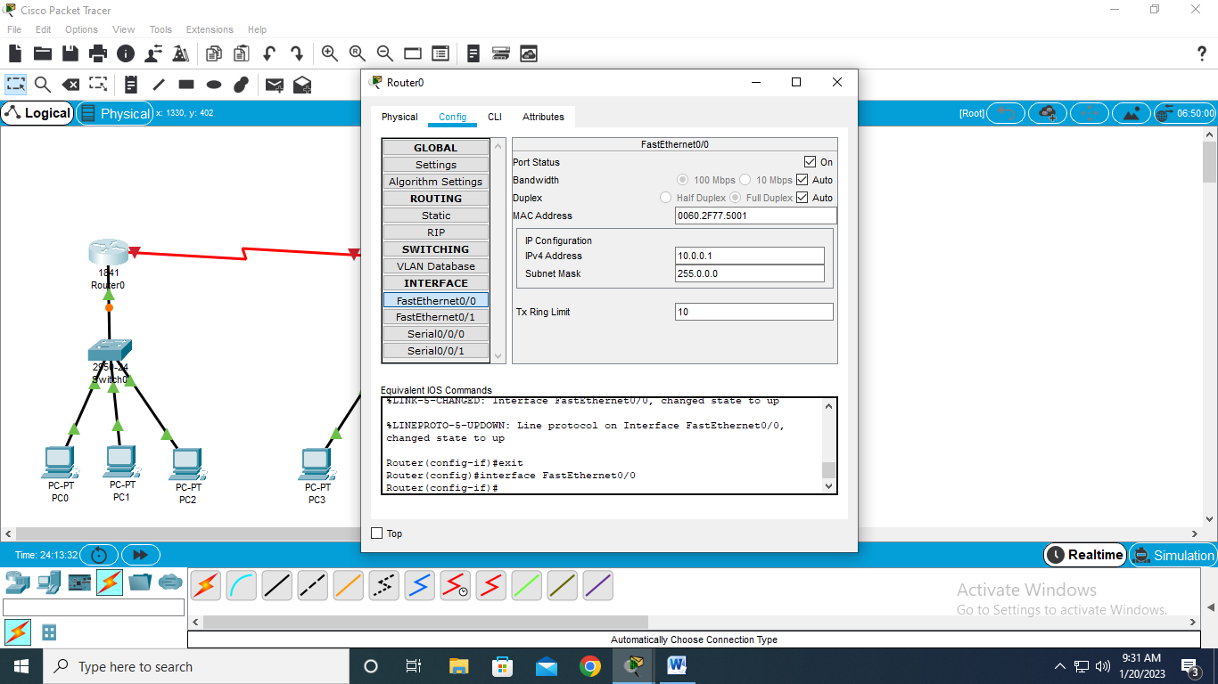

1. Add fastethernet IP address to each router2

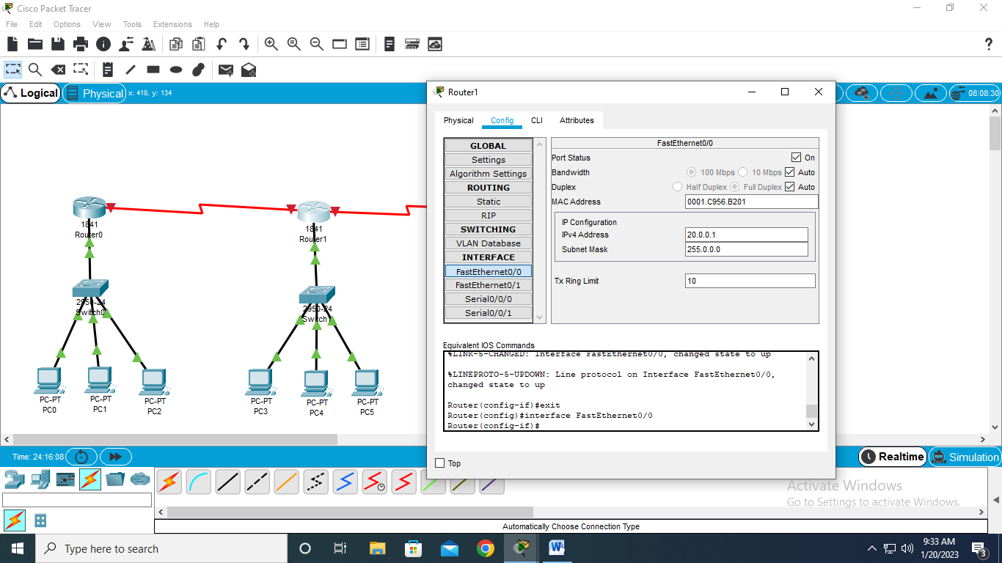

10)Add fastethernet IP address to each router3

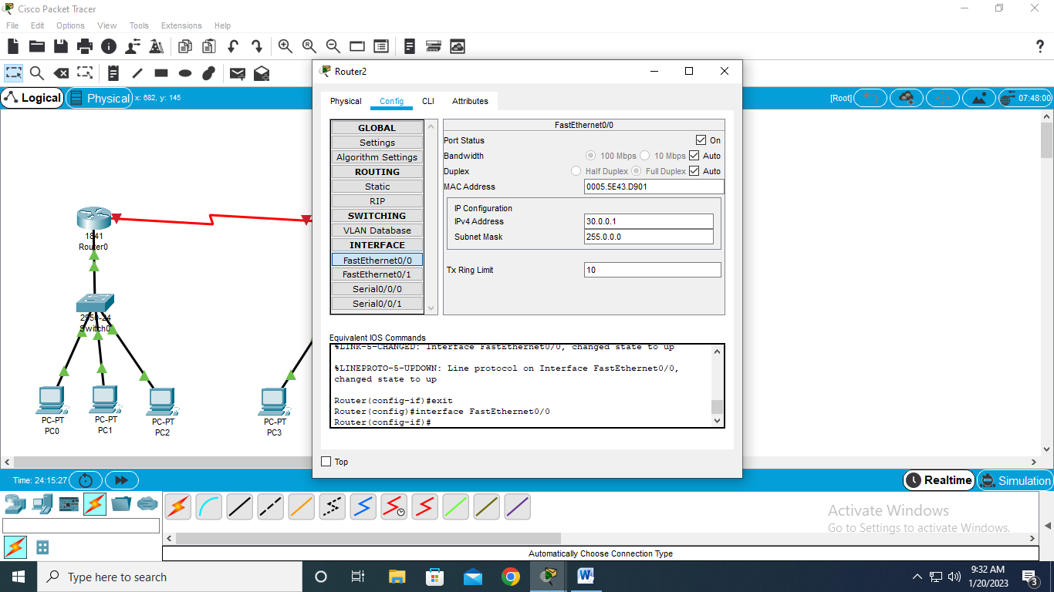

10)Add IP address to 1st group of pc

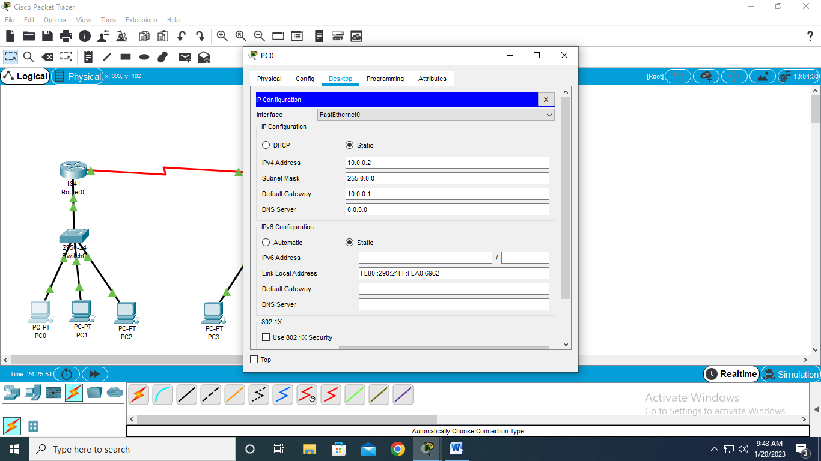

12)Add IP address to 2ndgroup of pc

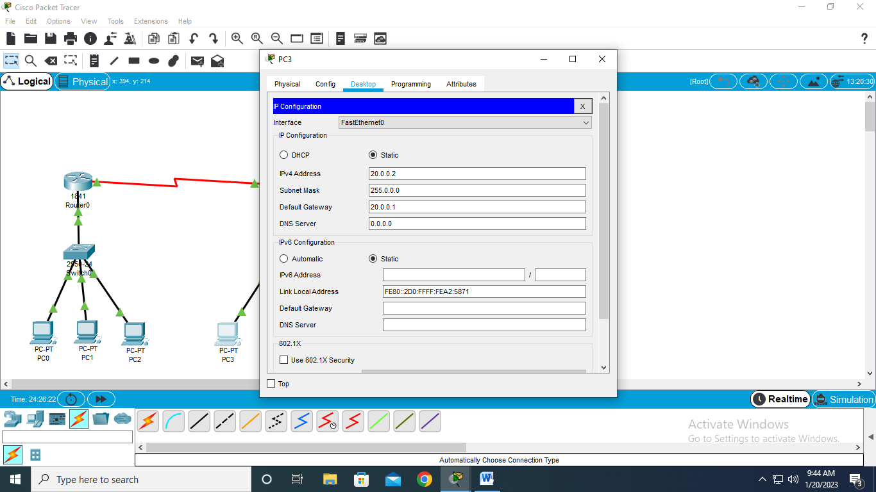

13)Add IP address to 3rdgroup of pc

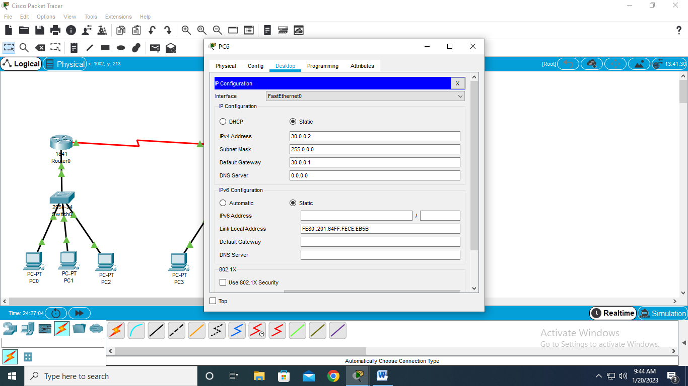

14)Add serial 0/0 to 1st router

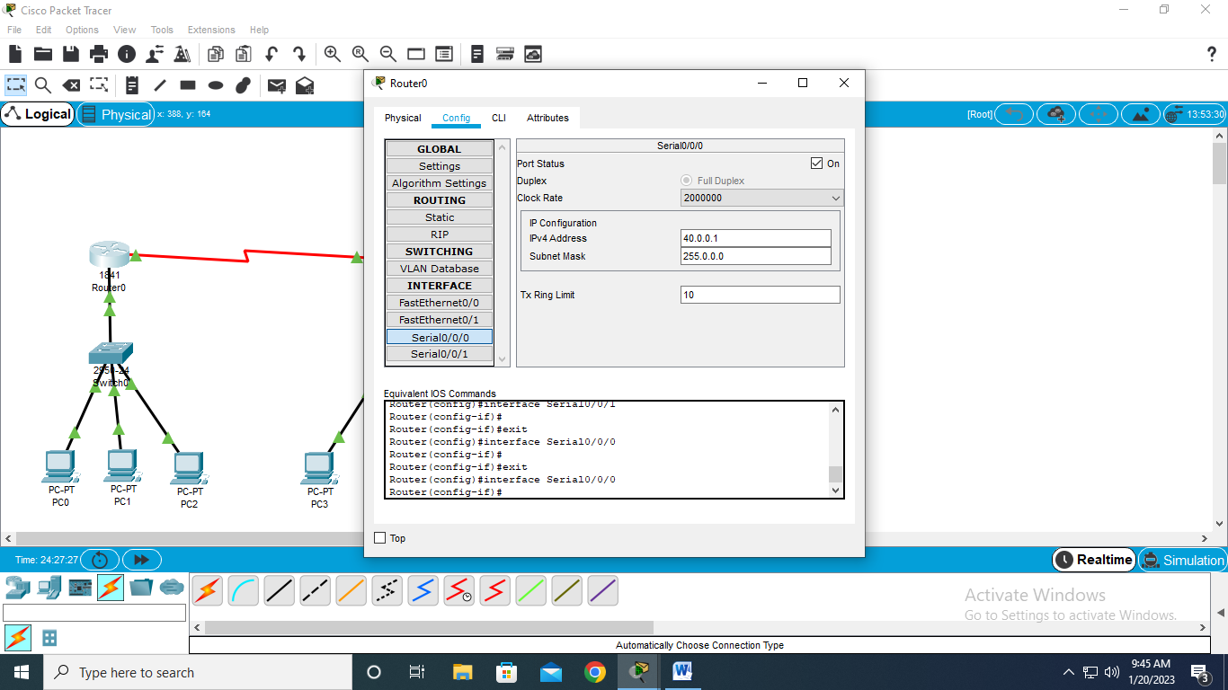

15)Add serial 0/0 to 2ndrouter

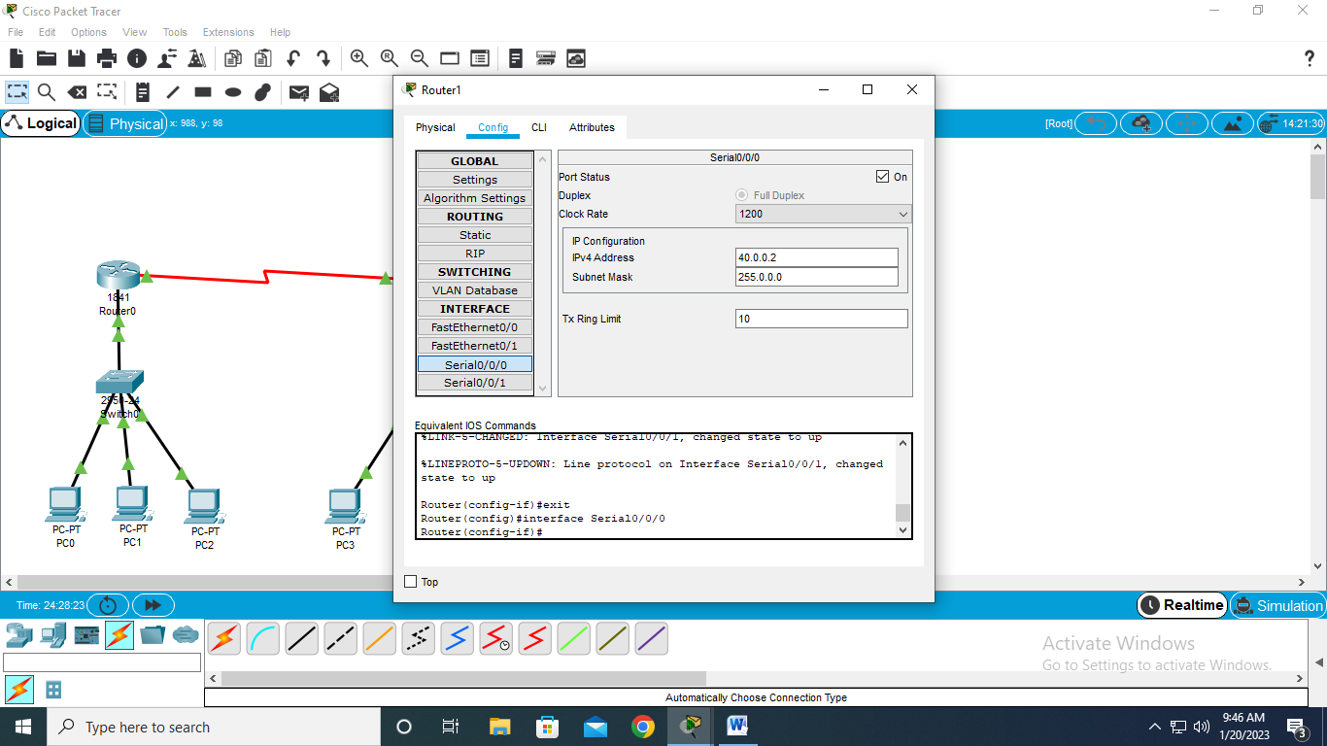

16)Add serial 0/1 to 2nd router

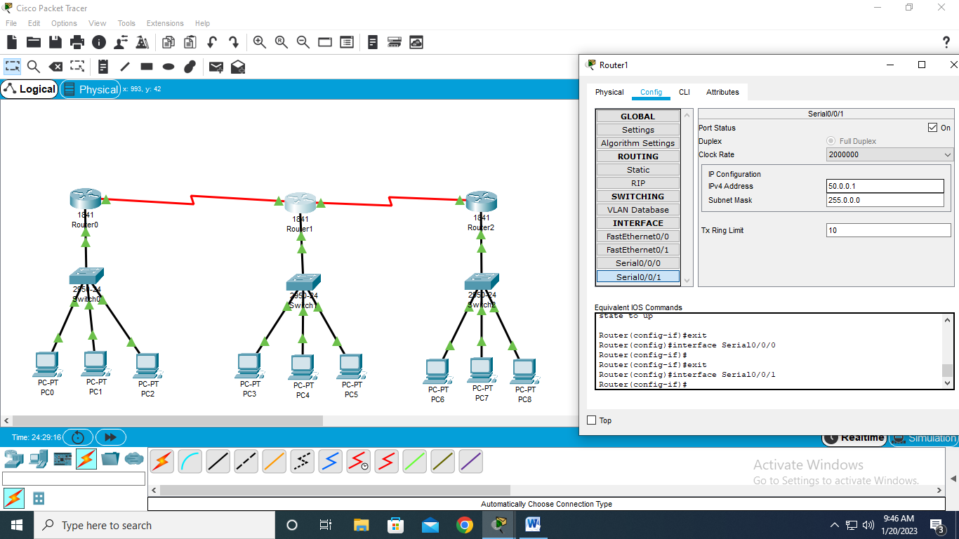

17)Add serial 0/0 to 3rdrouter

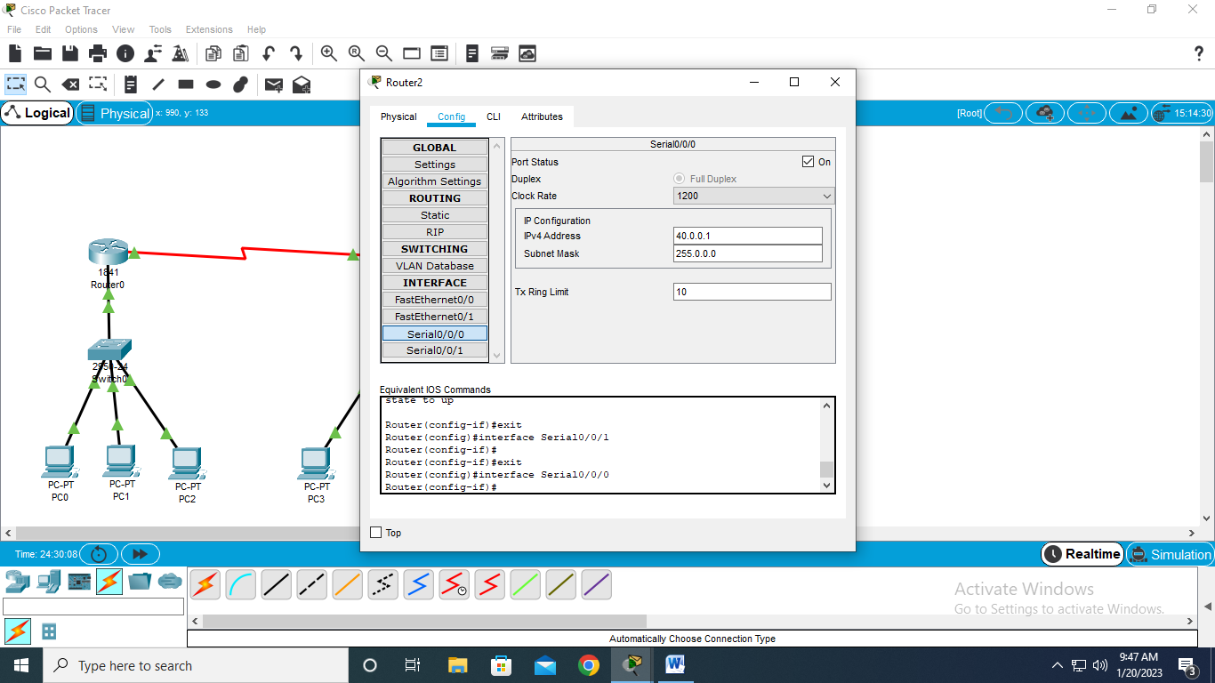

18)Add RIP to 1st router

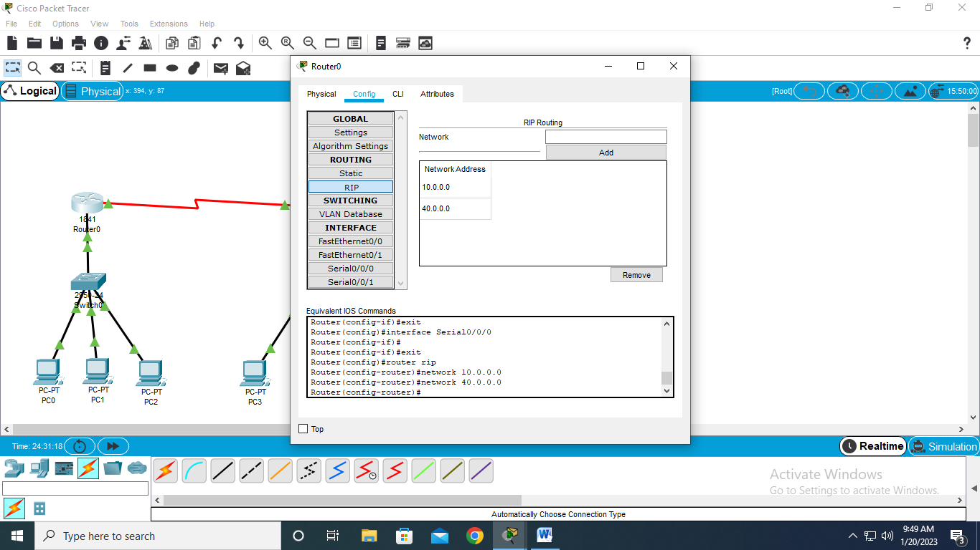

19)Add RIP to 2ndrouter

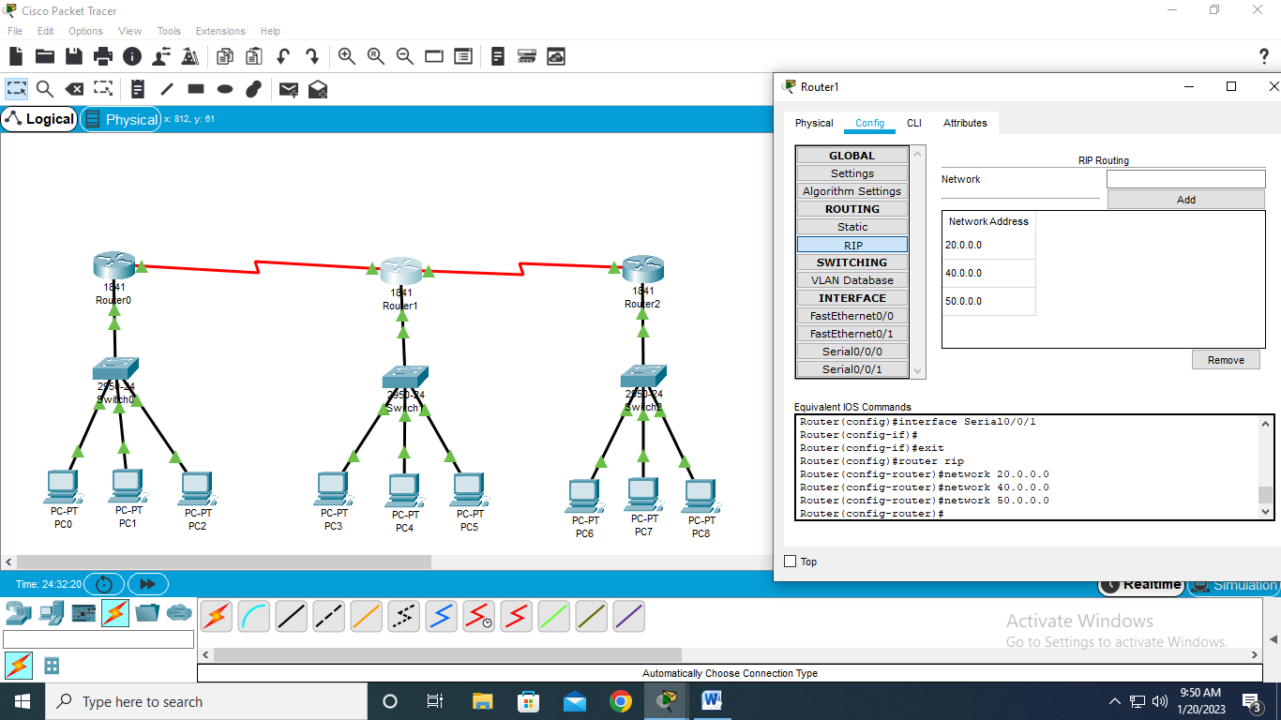

20)Add RIP to 3rdrouter

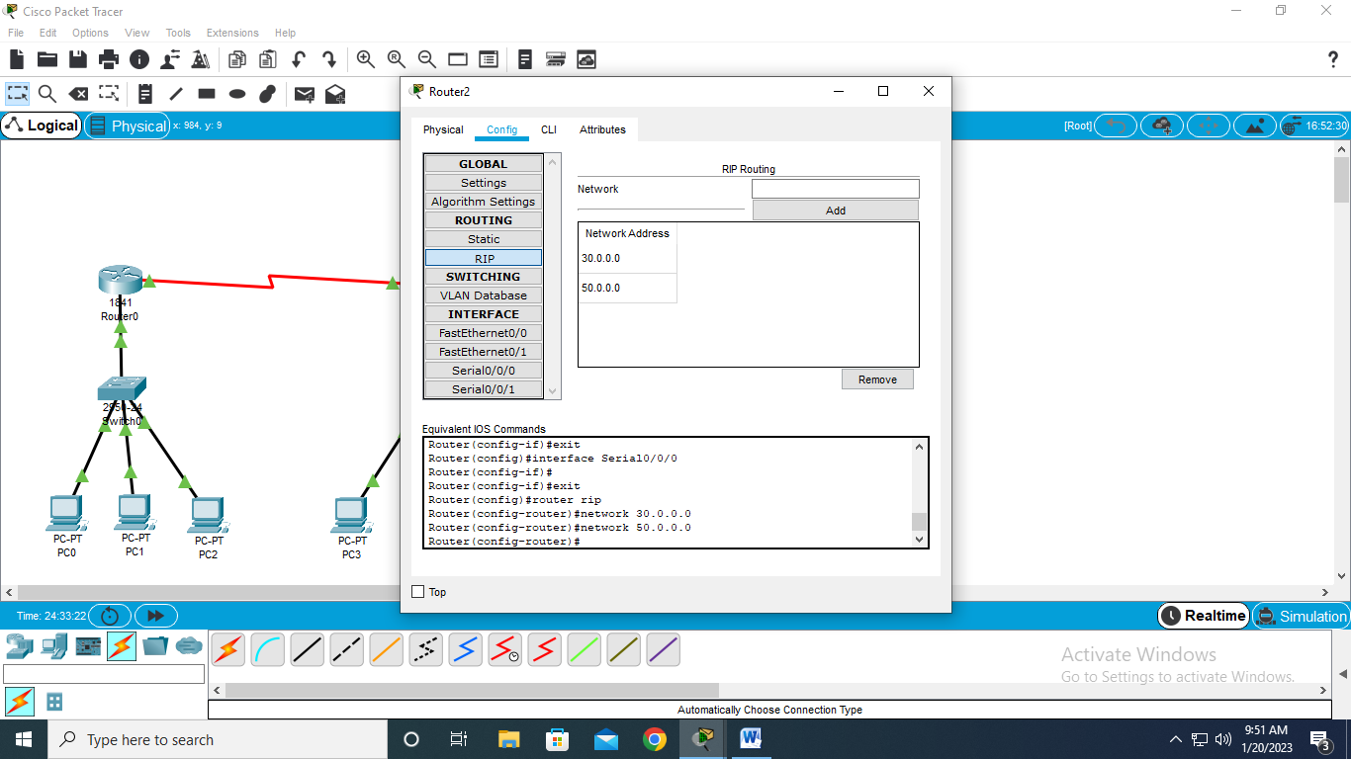

21)Simulation

